MOHAN SAI PRAGADA

Mohansai.pragada2019@vitstudent.ac.in

Assignment-4:

Develop a mobile application that takes the user input and sends it to IoT device (python code).print the received data in python shell.

Keep a text box to accept the user input integrate a submit button. Whenever user enters the text input in text box and clicks the button the data should be sent to IBM cloud using URL(HTTP API).

Software: IDLE , MIT & NODE RED APPS

**Code:**

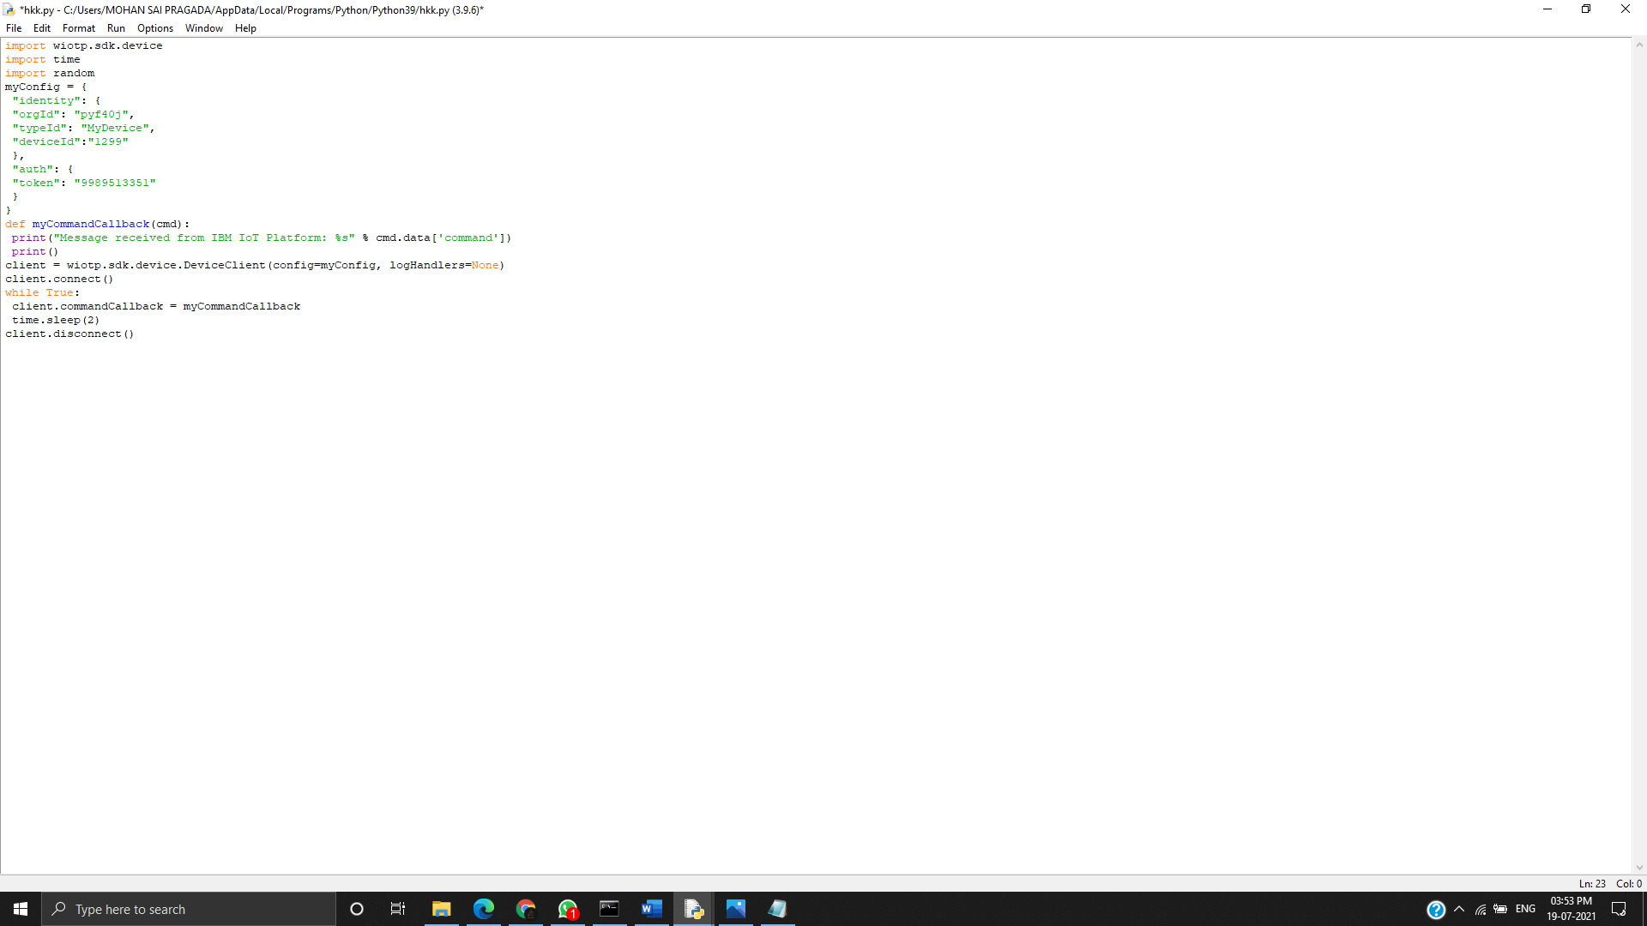

**Node red:**

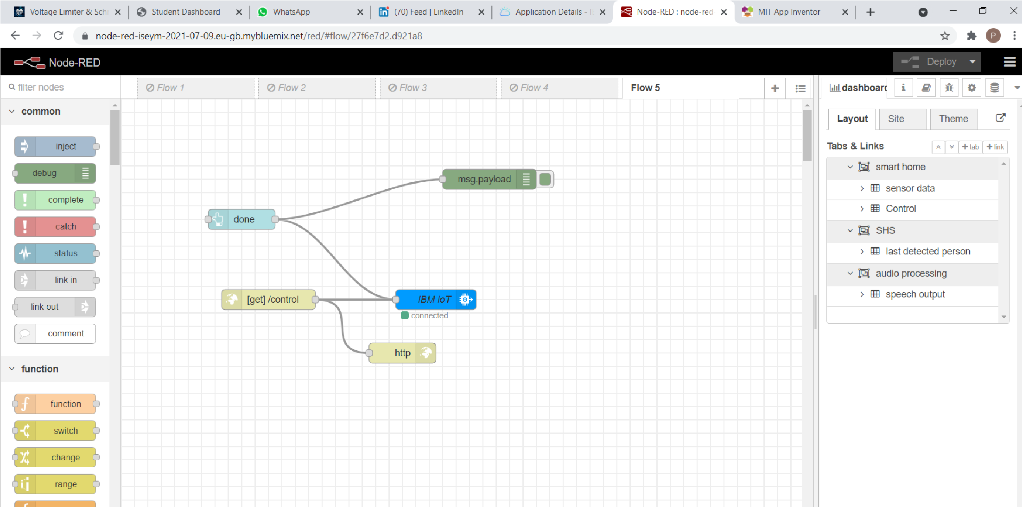

**MIT APP:**

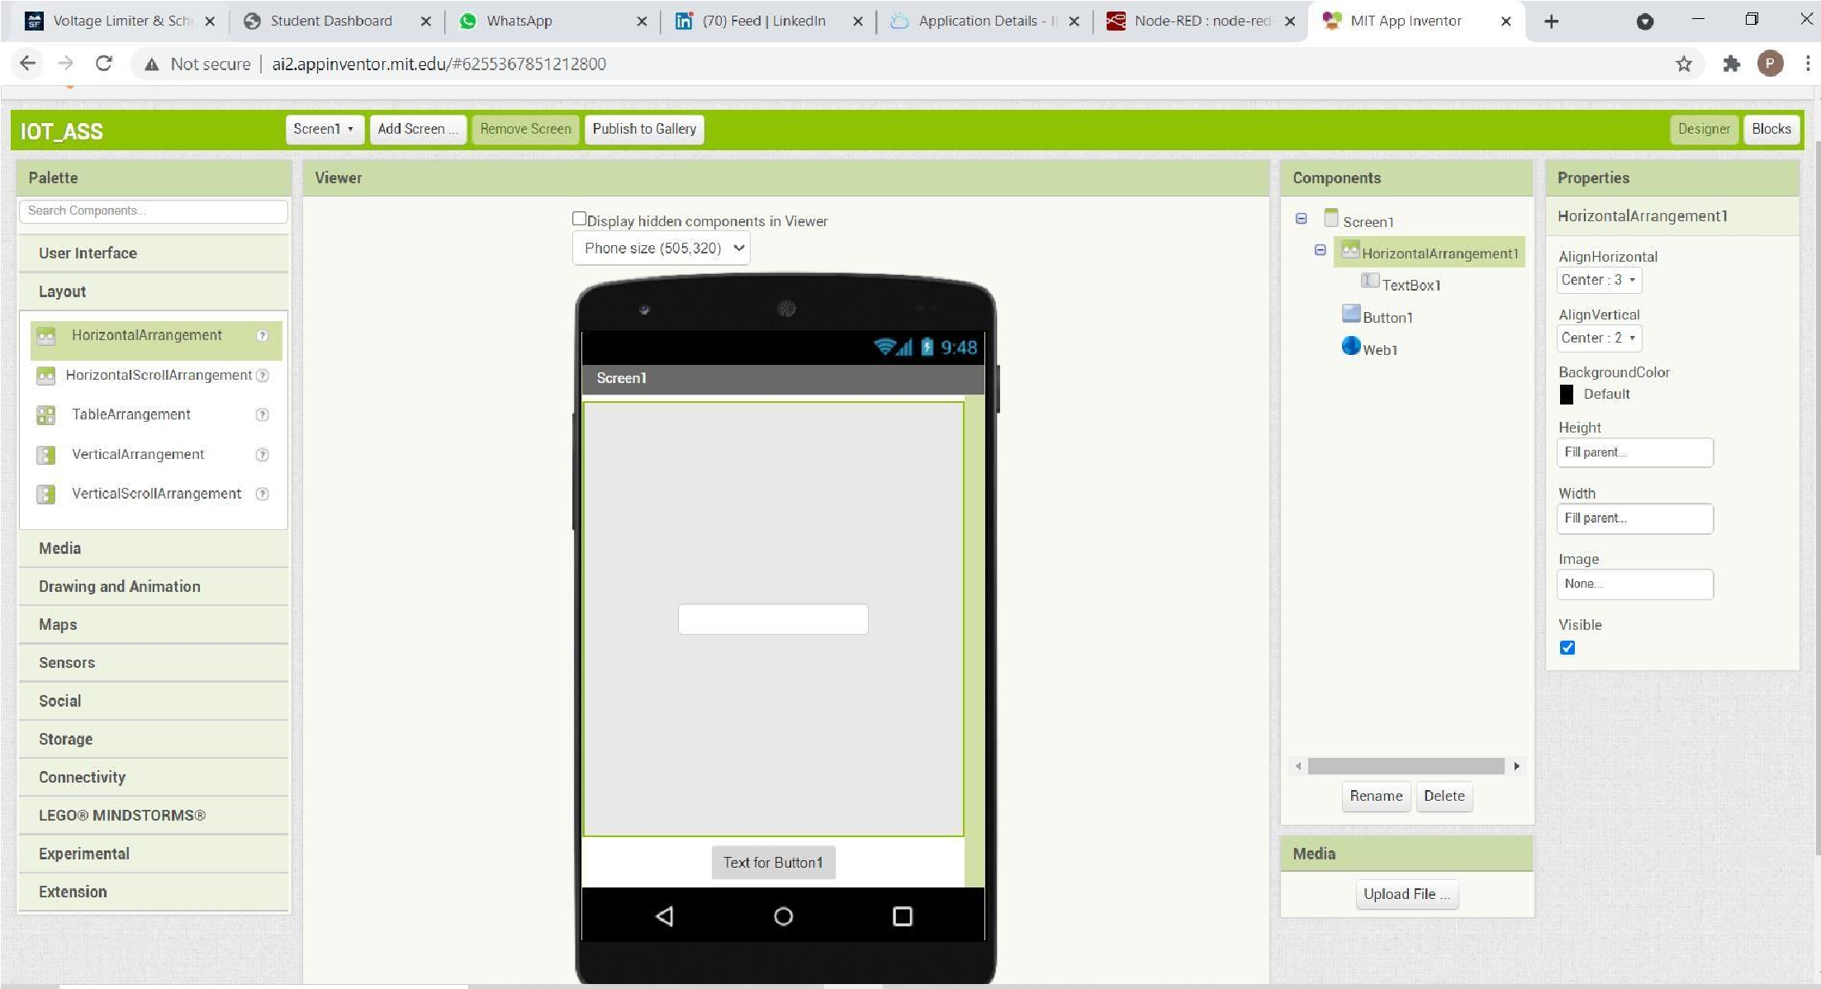

Blocks:

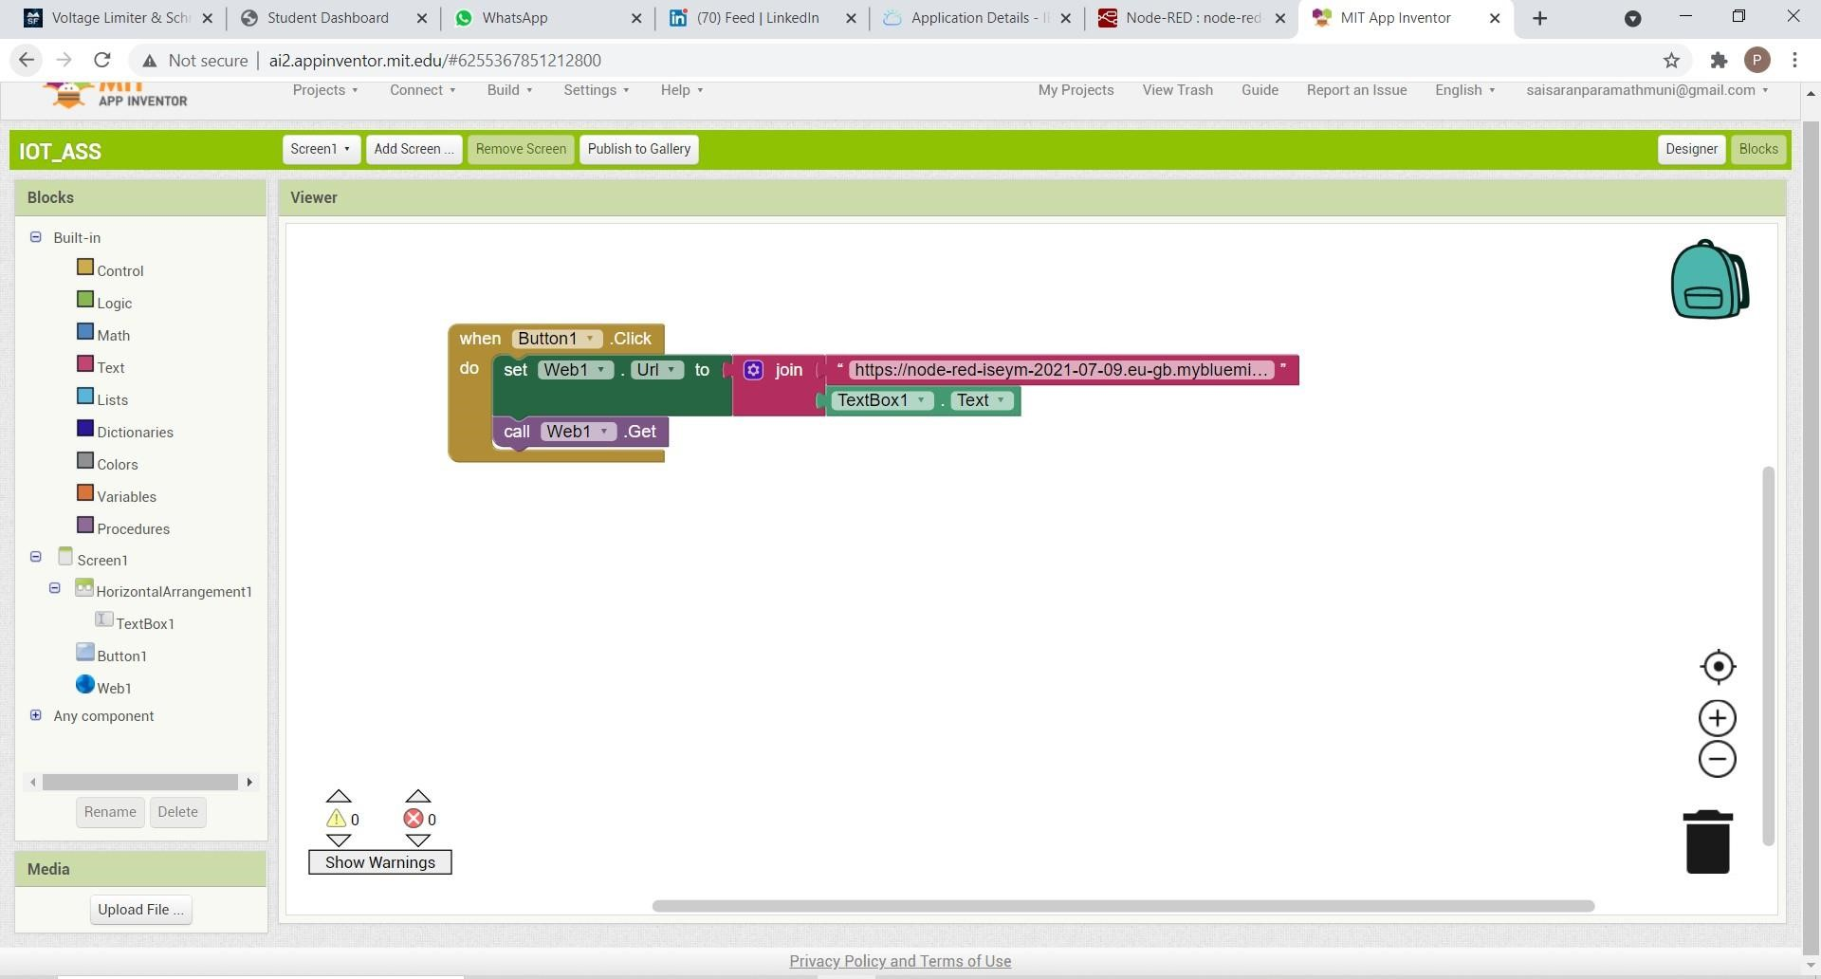

After building the blocks we have to connect the web application to phone

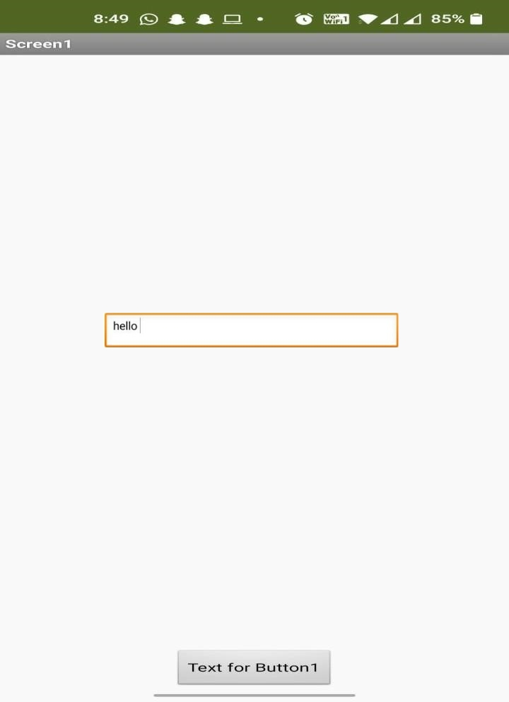

We can view it in the python shell

